Guidelines for resumption of WASH and behaviour change activities in the context of COVID-19
  - September 2021

Introduction and purpose
COVID-19 has brought much of Sightsavers’ work on aspects related to social behaviour change and community WASH activities to a slow down since becoming a pandemic in early 2020. This is despite the fact that WHO issued guidance in May 2020, that “Community-based WASH activities should continue, with amendments to include key information about preventing COVID-19 in settings where there are no cases of COVID-19. In settings where COVID-19 transmission is occurring, WASH messages should be repurposed to focus on preventing COVID-19 transmission.” (WHO, 2020) - resource link
This document is intended to provide clarity on specific tools, mechanisms, and policies that will be considered for F&E activities. Where appropriate we will apply any existing national tools or guidelines, and/or the RAMA tool(s) to inform our restart of WASH and behaviour change activities. We have provided example of tools and SOP’s below which can provides guidance to Sightsavers, implementing partners and Government staff on how to ensure the health and safety of themselves and the unintentional spread of COVID-19 in the community while implementing WASH and behaviour change activities.

How to use these guidelines:
Step 1. Use the decision tree to identify next steps
Step 2: Fill in Table 1: Activity table with all potential WASH and behaviour change related activities.
Step 3: Fill out additional tables or tools mentioned in the decision tree and identify needed mitigation measures
Step 4: Share with Sightsavers NTD technical team for sign off and review
Note: The proposed guidelines should not replace national guidelines. They should be used as an additional tool to ensure safe resumption of WASH and behaviour change activities.

Resources overview:
 | Resource | Use
TOOL 1 | Decision tree | Starting point of the process.  Use the decision tree to identify next steps and resources to use (tables, tools & annexes)
TABLE 1 | Activity table | Starting point in the decision tree for all activity resumption. Fill in with all WASH & behaviour change activities to resume.
RAMA TOOL | DSA RAMA  English Tool (Ctrl + Click for link)  French Tool (Ctrl + Click for link) | Use if your country is undergoing any aspect of the Targeted Design Assessment (TDA)
TABLE 2 | Mitigation table | To be filled in for all community and school interventions (one table per intervention)
ANNEX 1 | Activity table and mitigation table examples for Ethiopia WASH and behaviour change activities during COVID-19 | To be used as an example and help to fill in Mitigation matrices (Table 2) for each school or community based intervention.
ANNEX 2 | SOP for meetings | To be used for meetings and/or trainings that are taking place as part of your activity table
ANNEX 3 | Excerpt from the WHO Mass Gathering COVID 19 risk assessment tool (Ctrl + Click for link) | To be used to find additional mitigation measures to complete the relevant mitigation tables
ANNEX 4 | Risk mitigation measures for household visits & other home-based interventions | To be used to find additional mitigation measures to complete the relevant mitigation tables

Tool 1: Decision tree

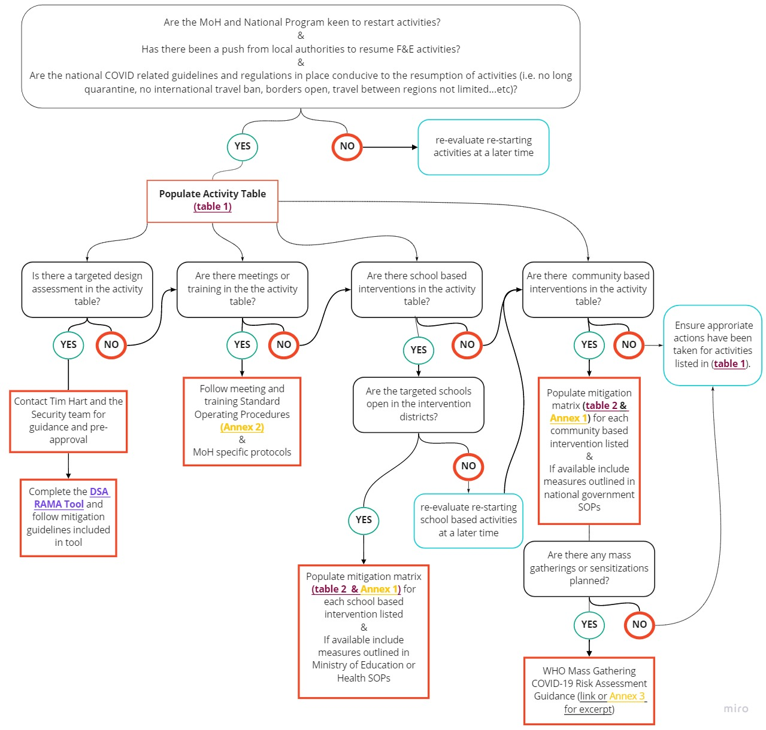

Table 1: Activity table
Table 1: Activity Table
Intervention/Activity | Type of activity (TDA, Meeting or training, School based activity, Community based activity)

Table 2: Mitigation table for WASH and behaviour change activities
Please describe here the intervention and it’s components. Be sure to focus on components of the intervention that may present as a ‘risk’. Interventions are considered as ‘risk’ if they involve activities that pose risk of amplification of COVID-19 transmission, interventions that involve personal contact/communication between/among individuals or travel of individual/individuals.
Examples of activity and mitigation tables from Ethiopia can be found in Annex 1.

Table 2: Mitigation Table
N.B.A table needs to be filled for each intervention listed in the activity table (Table 1) above
Intervention | Awareness & Mitigation Measures

Annex 1: Activity table and mitigation table examples for Ethiopia WASH and behaviour change activities during COVID-19

The table below provides an opportunity to develop or refine SOPs for implementing F&E Activities in the context of COVID-19. The lists of interventions are to be implemented under F&E BC project in Ethiopia in 112 districts of Afar, Somali and Southern Nations and Nationalities Peoples’ regions.

Table I: Activity table with list of F&E BC interventions and activities

SN | Intervention | Type of activity (Meeting or training, School based activity, Community based activity)
1 | Preparation and launching of interventions | District level meetings with public officials and implementers (health, education, water, CSOs and community representatives)
2 | School-based games for promotion of hygiene and sanitation in schools and community | Training of teachers, WASH coordinators and community group leaders
 |  | Game based teaching and gamified behaviour change for students
 |  | Sensitization of school and out of school community (WASH clubs, surrounding community)
 |  | Hygiene promotion in schools using IEC materials
3 | My clean and beautiful family: focusing on family using multi-channel campaign to improve hygiene behaviours | Training of district level facilitators on approaches
 |  | Training of health extension workers
 |  | Training of women groups (health development army)
 |  | Home visit by health extension workers for taking and printing of family pictures as behavioural nudge
 |  | Hygiene education by health extension workers through home visits
 |  | Facial cleanliness campaign through radio and/or SMS
4 | Sanitation marketing: Promotion of hygiene practices through microbusinesses for women | Training of district level facilitators
 |  | Organize/Establish women microbusiness groups
 |  | Training for women groups
 |  | Hygiene promotion through women groups
5 | Adapting of job aids for HEWs and community leaders/agents | Adapt existing job aids to make more visual and targeted
 |  | Orient HEWs on new tools
 |  | Orient HDAs/community leaders on the new tools
 |  | Promote hygiene behaviour using the tools

Table II: List of F&E BC interventions and possible mitigation measures

S/N | Intervention | Awareness & Mitigation Measures
1 | Preparation and launching of interventions | - Consider local guidelines or rules before organizing launching events  - Consider remote launching using notification letters, email, SMS, WhatsApp, Telegram, radio, leaflets, mobile phone, posters or media to avoid personal contact  - Observe training, gathering or workshop guides if there’s such event for this intervention  - Incorporate COVID-19 messaging into events or tools or communications  - Identify influencers that help spread information  - If there’s a need to organize an event,  - Limit number of attendants  - Consider several events with limited number of participants  - Ensure appropriate infection prevention measures are in place (hand washing stations with soap, sanitizers, bins) and PPEs (masks, gloves and gowns if appropriate) are in place  - Use outdoor or well-ventilated venues that allow physical distancing  - Ensure availability of medical response plans (isolation units for those having symptoms, facilities for COVID-19 testing and management)  - Visual reminders for respiratory etiquette (Wear masks, cough into your elbow, do not spit, do not touch your face, avoid handshaking, observe physical distancing)  - Consider temperature screening  - Optout for those at risk of severe illness (with pre-existing chronic illness (over 60 years of age, with chronic illnesses such asthma, hypertension, diabetes, HIV/AIDs etc), ensure alternative methods to address these groups
2 | School-based games for promotion of hygiene and sanitation in schools and community | - Consider any national or local government laws, regulations, or mandates related COVID-19 mitigation measures in schools  - Engage teachers, school administrators and parents with available possible and safe means in planning and implementation process for any mitigation measure  - Observe training, gathering or workshop guides if there’s such event for this intervention  - Ensure the following mitigation measures to reduce transmission in intervention schools  - Physical distancing-maintain 2 meters distance between individuals  - Avoid sharing books, supplies, games, or other learning aides, if sharing is necessary due to limited supply, clean and disinfect between different students.  - Post signs and make frequent announcements encouraging physical distancing (≥2 meters) at all times.  - Schedule events to some students on certain days (e.g., Monday, Wednesday, Friday) and others to attend on remaining days (e.g., Tuesday, Thursday, Saturday)  - Ensure there are adequate handwashing stations or alcohol-based hand rub dispensers  - Post signs with visual cues and school-wide announcements encouraging hand hygiene.  - Make sure messaging are age appropriate and include information about when and how to practice hand hygiene  - Ensure individuals wear a cloth face covering, face coverings are particularly important when physical distancing is not possible and individuals are indoors with poor ventilation, for example students in a crowded classroom.  - Students should be frequently reminded not to touch their eyes, nose, or mouth or face coverings. Children under age 2, or anyone who has trouble breathing, is unconscious, incapacitated, or otherwise unable to remove the mask without assistance should not wear cloth face coverings.  - Cover coughs and sneezes using an elbow or a tissue. Dispose of the tissue and clean hands immediately.  - Ensure there are signs with age-appropriate visual cues depicting how to cover coughs and sneezes  - Ensure cleaning and disinfection is frequented on touched surfaces at least once a day, or more frequently if possible.  - Increase ventilation and air flow.  - Provide information (e.g., written or pictorial instructions) about when and how to clean and disinfect  - Consider daily temperature screening  - Optout for those at risk of severe illness (with pre-existing chronic illness (over 60 years of age, with chronic illnesses such asthma, hypertension, diabetes, HIV/AIDs etc), ensure alternative methods to address these groups  - Avoid school-community link (if the intervention has purpose of reaching community through schools, please use means other than physical contact)
3 | My clean and beautiful family: focusing on family using multi-channel campaign to improve hygiene behaviours | - Consider any national or local government laws, regulations, or mandates related COVID-19 mitigation measures  - Engage influential community groups with available possible and safe means in planning and implementation process for any mitigation measure  - Observe training, gathering or workshop guides if there’s such event for this intervention  - Direct community members to continue practicing personal protective measures.  - Provide guidance on how to implement physical distancing measures such as cancelling gatherings, altering schedules or operating hours to reduce mixing, increasing physical space between individuals.  - Continue to provide guidance on control measures (e.g., face mask, hand sanitizers)  - Provide guidance on what to do when people get sick  - Provide guidance for establishing handwashing stations that include soap and water, alcohol-based hand sanitizers, or chlorine solution  - Encourage every person to wash hand frequently  - Provide PPEs for HEWs and HDAs  - Household visits to be conducted outside, and household members maintaining social distancing  - Limit contact for less than 15 minutes at each household  - Provide guidance on cleaning and disinfecting frequently touched surfaces  - Provide guidance on how to clean and disinfect home when someone is sick.  - Isolate confirmed COVID-19 cases until no longer considered infectious  - Consider temperature screening  - Optout for those at risk of severe illness (with pre-existing chronic illness (over 60 years of age, with chronic illnesses such asthma, hypertension, diabetes, HIV/AIDs etc), ensure alternative methods to address these groups
4 | Sanitation marketing: Promotion of hygiene practices through microbusinesses for women | - Consider any national or local government laws, regulations, or mandates related COVID-19 mitigation measures  - Observe training, gathering or workshop guides if there’s such event for this intervention  - Make sure workplaces for women groups are clean and hygienic  - Surfaces need to be wiped with disinfectant regularly  - Promote regular and thorough handwashing  - Put sanitizing hand rub dispensers in prominent places around the workplace  - Display posters promoting handwashing  - Promote good respiratory hygiene/etiquette in the workplace  - Display posters promoting respiratory hygiene.  - Ensure that face masks and / or paper tissues are available at your workplaces, for those who develop a runny nose or cough, along with closed bins for hygienically disposing of them  - Optout for those at risk of severe illness (with pre-existing chronic illness (over 60 years of age, with chronic illnesses such asthma, hypertension, diabetes, HIV/AIDs etc), ensure alternative methods to address these groups
5 | Adapting of job aids for HEWs and community leaders/agents | - Consider any national or local government laws, regulations, or mandates related COVID-19 mitigation measures  - Observe training, gathering or workshop guides if there’s such event for this intervention  - Review available job aids and tools and include key information about preventing COVID-19

Annex 2: Meeting SOP
Notice: The proposed event should take place according to the below agreed standard operating procedure, while abiding by all existing Government proscribed mitigation measures for preventing COVID-19.
- Pre-requisite questions:
The following needs to be collected by the meeting organizer. This information should be used to guide decisions regarding the event and the mitigation measures to implement.
- Current health prevention measures in place by host country that may affect the event (e.g. banning gatherings with more than a certain number of individuals, etc.).
- Expected number of participants?
- Will travel (international or regional) be necessary for participants?
- The number of participants coming from countries or areas/regions affected by the COVID-19 outbreak* within 14 days before the event?
- Current travel restrictions of host country (both national and international)?
- Estimated percentage of participants who may be considered at risk (age > 65, pre-existing conditions, health care workers, or other responders).
- Will there be Head of State / Head of Government / Ministerial or deputy ministerial involvement (number)?
- Will there be side events in addition to the main mass gathering?
- Will there be different meeting sites for the various events?
- What measures are in place to minimize close contact between participants?
- What measures could be put in place specifically regarding remote attendance by both participants and speakers?
- What are seen as the major impact(s) of postponement of the meeting (financial, operational, reputational, etc.)?
- The characteristics of the event’s designated venue(s) (location, size/type, indoor/outdoor, crowd density, etc.)
- • The number and key characteristics of the expected participants in the event (age, health status, provenance, international/local travel to event, etc.)
- • The expected interactions among participants occurring during the event (closeness of contact, etc.)
- • The expected duration of the event
- What is the state of the network infrastructures (i.e internet, 4G network…etc) in the country/region?

- Mitigation measures:

Prevention and control measures can be applied throughout the event’s timeline - in the planning phase, the operational phase, and the post-event phase.

Planning phase
The planning phase is the period preceding the event, when plans are developed, tested, and revised. Prevention and control measures applicable during this phase include:
- Establishing direct links and channels of communication between event organizers, health authorities, and other relevant authorities

- Ensuring alignment of the event plan with wider national guidelines, including number of participants, preventive measures,

- Making provisions for detecting and monitoring event-related cases of COVID-19, reducing the spread of the virus, managing and treating ill persons, disseminating public health messages specific to COVID-19 in culturally appropriate ways and in languages used by participants

- Modifications of the event (related to the venue)
    - Consider hosting the event, at least partially, online/remotely/virtually. Consider promoting online participation to the event (i.e. training or meeting) while maintaining a simultaneous in-person meeting with a limited capacity.
    - Consider hosting the event outdoors rather than indoors

- Modifications of the event (duration)
    - Keeping the duration of the event to a minimum to limit contact among participants

Operational phase
The operational phase is the period during which the delivery of the event services takes place. Prevention and control measures applicable during this phase include:

• Modifications of the event (related to the venue)
- Adjusting the official capacity of the venue to enable sufficient distancing

- Ensuring availability of handwashing facilities with soap and water and/or hand rub dispensers

- Ensuring regular and thorough cleaning and disinfection of the venue by designated staff

- Regulating the flow and density of people entering, attending, and departing the event (e.g. by increasing the frequency of transport, staggering arrivals, registering attendees, numbering entries, designating seating, marking the floor)

• Modifications of the event (related to the participants)
  - Use of microphones enable people to be heard when speaking through a mask at a distance

- Advising people to observe physical distancing, respiratory/cough etiquette, and hand hygiene practices
- Physical distance (ideally 2m, if not: at least, an adult step, or 1m)
- Systematic hand washing with soap and soap or hand sanitizers
- Avoid physically greeting other attendees with handshakes or hugging
- Use of face masks to be mandatory at all times

- Advising people with higher risk of transmitting COVID-19 that they should not attend the event (e.g. those with COVID-19 symptoms, contacts of COVID-19 cases during their period of quarantine, or those coming from countries/areas with community transmission of COVID-19)

- Advising people with higher risk of developing severe illness from COVID-19 (e.g. aged ≥65 years or with pre-existing medical conditions), and individuals in contact with higher-risk patients (e.g. residents in same household, long term care facility employees etc.), that they should not attend the event, or making special arrangements for them

- Risk communication
- Crafting and delivering culturally appropriate and language-specific messages to participants and the public

- Disseminating key messages in line with national health policies, including:
- Visual reminders on basic preventive measures, especially physical distancing, respiratory/cough etiquette, and hand hygiene practices
- Visual reminders on action and steps to be followed by people developing symptoms of COVID-19
- Visual reminders on recommended/required use of face masks and other personal protective equipment (PPE)

- Surveillance of participants, aimed at detecting and managing individuals developing symptoms during the event
- Participants should be screened upon arrival for suspected symptoms of Covid-19

- Detection and management of event-related COVID-19 cases should be conducted in accordance with national policies and regulations, within the framework of national health systems

- Suspected or identified cases should be treated according to National Guidelines and, if necessary, referred to the nearest Health Centre immediately, and the entire group should be advised to quarantine.

Post-event phase
The post-event phase follows the conclusion of the mass gathering. Prevention and control measures applicable during this phase include:
- Liaison between event organizers and health authorities, along the following lines:
- In case participants or staff develop symptoms during the event, event organizers should liaise with national and local health authorities, as well with those of the participant’s home city or country, and facilitate sharing of information

- Individuals who develop symptoms upon returning to their home city or country should be advised to contact public health authorities about their potential exposure

- Liaison between event organizers and health authorities is required to ensure that systems are in place to detect cases arising in the local population as a consequence of the event

Annex 3: Excerpt from the WHO Mass Gatherings in the context of COVID-19 risk assessment tool
Implementation of F&E activities often involves some form of gathering during training of implementers and during community sensitization or behaviour change triggering sessions. WHO recommends that any decision to restrict, modify, postpone, cancel, or proceed with holding a mass gathering should be based on a rigorous risk assessment exercise, tailored to the event as per the WHO mass gathering COVID-19 risk assessment tool The risk assessment should be undertaken by local and national public health authorities and event organizers with input from other relevant authorities (emergencies, transport, safety, and security etc.), based on the following considerations:
- Normative and epidemiological context in which the event takes place - the host country’s existing regulations on public health and social measures to control spread of COVID-19, which reflects the intensity of transmission in the area.
- Evaluation of risk factors associated with the event – appraisal of the likelihood that the event may contribute to the spread of COVID-19 and that the health services capacity may be exceeded by such spread.
- Capacity to apply prevention and control measures - the ability to implement actions that can reduce the risks associated with the event.
WHO further recommends that the overall risk associated with a mass gathering event is the outcome of a process that incorporates (i) the risk of amplified COVID-19 transmission associated with the event and its expected burden on the health system and (ii) the capacity of health authorities and event organizers to prevent and control such risks.
It is recommended that the WHO mass gathering COVID-19 risk assessment tool be adopted to inform the decision on whether or not to hold gatherings related to F&E implementation. The decision tree provides an overview of the process for determining the risk of COVID-19 spread should a mass gathering be held. District and regional level health officials (to be identified based on country health structure) will be required to complete this risk assessment tool. Gatherings will only continue in places that will score either “very low”, “low” or “moderate risk” in the decision matrix. The decision matrix combines the risk score and the mitigation score to provide a colour determination, which identifies the total risk of transmission and further spread of COVID-19 and provides a recommendation on whether an event should be held and if further mitigation measures are advised. The colour determination key below the decision matrix describes the total risk for each colour and if any recommendations are suggested
Covid-19 infection risk mitigation measures for any F&E gatherings
The following measures are recommended for consideration during gatherings related to F&E activities.
- Hosting the event, at least partially, online/remotely/virtually
- Hosting the event outdoors rather than indoors
- Adjusting the official capacity of the venue
- Ensuring availability of handwashing facilities with soap and water and/or hand rub dispensers
- Ensuring regular and thorough cleaning and disinfection of the venue by designated staff
- Regulating the flow and density of people entering, attending, and departing the event (e.g. by increasing the frequency of transport, staggering arrivals, registering attendees, numbering entries, designating seating, marking the floor)
- Advising people to observe physical distancing, respiratory/cough etiquette, and hand hygiene practices
- Advising people with higher risk of transmitting COVID-19 that they should not attend the event (e.g. those with COVID-19 symptoms, contacts of COVID-19 cases during their period of quarantine, or those coming from countries/areas with community transmission of COVID-19)
- Advising people with higher risk of developing severe illness from COVID-19 (e.g. aged ≥65 years or with pre-existing medical conditions- Chronic illnesses such as asthma, hypertension, diabetes, HIV/AIDs etc), and individuals in contact with higher-risk patients (e.g. residents in same household, long term care facility employees etc.), that they should not attend the event, or making special arrangements for them
- Keeping the duration of the event to a minimum to limit contact among participants
- Disseminating key messages in line with national health policies, including:
- Visual reminders on basic preventive measures, especially physical distancing, respiratory/cough etiquette, and hand hygiene practices
- Visual reminders on action and steps to be followed by people developing symptoms of COVID-19
- Visual reminders on recommended/required use of face masks and other personal protective equipment (PPE)
- Isolation facilities should be made available at the event site for participants who develop symptoms, for initial assessment and triage by designated medical staff, and for their transportation to a health facility if needed
- In case participants or organisers develop symptoms during the event, event organizers should liaise with national and local health authorities, as well with those of the participant’s home city or country, and facilitate sharing of information

Annex 4: Risk mitigation measures for household visits & other home-based interventions:
TEN DAILY RISK ASSESSMENT QUESTIONS
These measures are adapted from the USAID CORE GROUP POLIO - GLOBAL HEALTH SECURITY PROJECT . The daily safety risk assessment should be reviewed by IPs or CHAs or PHOs along with the CHVs before they are sent into the community for F&E Interventions.
Is anyone in your household experiencing symptoms of COVID-19 such as fever, difficulty breathing, or coughing? If yes, you should not conduct house-to-house visits to avoid risk of spreading the disease to others. Also notify the health system, isolate the sick person, have the patient wear a mask, seek testing if available, observe other household members for symptoms, and remain home for at least 14 days to avoid spreading the disease.
- Does your government allow house-to-house visits?
- Does your NGO/INGO allow you to conduct house-to-house visits?
- Can the volunteer practice social distance during house-to-house visits?
- Can the volunteer avoid large gatherings?
- Does the volunteer have hand sanitizer and a face mask?

- If you answer NO to the any of the above questions, STOP. Do not conduct house-to-house activities.
- If you answer YES to ALL the questions above, PROCEED:

- Can this activity be done remotely through mobile messaging such as SMS, WhatsApp, Telegram, radio, leaflets, mobile phone, or posters to avoid personal contact?
- Can this information be disseminated by phone or any other means to an influential leader who can communicate to community members while practicing social distancing and safe communication practices?
- Can this information be disseminated using a loudspeaker mounted to a vehicle, motorbike, or bicycle?
- Can the information be disseminated using a megaphone?
- The number of households visited, and days or hours worked cannot be limited to minimize exposure.
➢ If you answer NO to any of above questions, PROCEED with safe house-to house visits and minimize direct contact when possible.
➢ If you answer YES to any of the above questions, conduct surveillance and health promotion at a distance.

Dos and Don’t’ s
Always
- Cough into your elbow
- Do not spit
- Do not touch your face
- Stop working and self-isolate or report to a health facility if you are ill
- Avoid handshaking
- Avoid all forms of physical contact
- Observe physical distancing by standing 1 to 2 meters away from others

Before the house-to-house visit
- Minimize direct contact: Use social media, mobile phone, megaphone instead
- Avoid wearing jewellery, watches or other things that would need to be cleaned afterwards
- Make sure you have face mask and sanitizer and use it frequently

During the house-to-house visit
- Wear face mask
- Always stand two meters away from others
- Do not enter the houses in homesteads. All household visits should be done outside of the house. CHVs (Visiting person) should not enter homes and should avoid using spaces that are enclosed, poorly ventilated, or indoors.
- Avoid shaking hands or other physical greetings or contact
- Use large format IEC materials to maintain distance (posters and banners)
- Limit duration of visit (not more than 15 minutes)
- Leave behind leaflets
- Refer all suspected COVID-19 cases for testing
- Wash their/your hands frequently, preferably on arrival to each house. Where possible give CHVs alcohol-based hand rub to take with them. Otherwise CHVs should wash hands with soap at public facilities or at household facilities that are outside. If this cannot be maintained at sufficient frequency, then consider doing remote forms of F&E and community engagement.

After the house-to-house visit
- Designate a space for removing and cleaning clothing at home
- Immediately wash your hands with soap or use sanitizer
- Clean/disinfect pens, megaphone, clipboard, and other items with bleach mixed with water

We work with partners in low and middle income countries to eliminate avoidable blindness and promote equal opportunities for people with disabilities.
www.sightsavers.org
www.sightsavers.org
Registered charity numbers 207544 and SC038110

