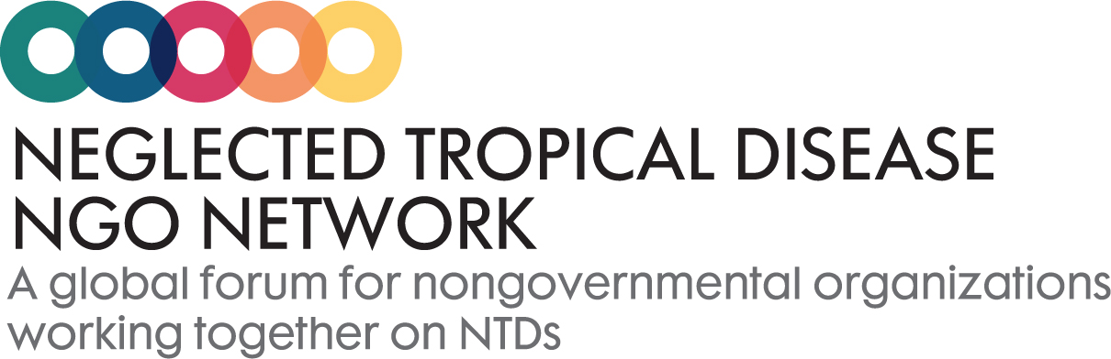

The Neglected Tropical Disease NGO Network takes an inclusive approach to membership. All NGOs that wish to make a lasting contribution to the control and elimination of NTDs, and who believe more can be achieved in partnership than can be done in isolation are welcome. We are joined by many other interested stakeholders (WHO, donors, pharmaceutical companies, etc) who interact as active observers, contributing to activities but without the right to vote on organisational matters.
The process for applying for membership is:
- Complete this membership form.
- Representatives from at least two NNN member organisations need to act as references for the incoming NGO.
- The Executive Committee reviews and determines the outcome of such applications at its next meeting*.
- Each member confirms its membership every five years.

*New membership applications are reviewed by the NNN Executive Committee on a quarterly basis.

The NNN reserves the right for dismissal of any organization previously holding membership status upon finding that the member has:
a. Taken a position publicly which is in conflict with the adopted policy of the NNN; or
b. Brought the NNN into disrepute.
Any member so removed from membership shall not be entitled to a refund on any funds previously remitted to the NNN.
NNN Membership Form

1. Name of your organization:

2. Please select how your organization wishes to participate in the NNN.
As a member
As an observer
We do not wish to participate.

3. Please briefly state your organization’s motivation for joining the NNN in the space below.

4. Which NTDs does your organization work on? (select all that apply)
Buruli ulcer
Chagas disease
Dengue and Chikungunya
Dracunculiasis (guinea-worm disease)
Echinococcosis
Foodborne trematodiases
Human African trypanosomiasis (sleeping sickness)
Leishmaniasis
Leprosy (Hansen's disease)
Lymphatic filariasis
Onchocerciasis (river blindness)
Rabies
Schistosomaisis
Soil-transmitted helminthiases
Taeniasis/Cysticercosis
Trachoma
Yaws (Endemic treponematoses)
Other (please specify)

5. Please provide your organization's annual expenditure on NTDs (in USD, GBP, or Euro).

6. If possible, please provide the names of the countries in which your organization is working.

7. Which components of the BEST Framework does your organization support? (select all that apply)
Behaviour
Environment
Social Inclusion and Equity
Treatment and Care

8. Please provide a name and contact information for two NNN member organizations sponsoring application.

First Sponsor Organization:
Name
Contact

Second Sponsor Organization:
Name
Contact

9. Please provide the name of an organizational contact point and email for any NNN communications.
Contact
Email

10. To be included on the NNN website, please send your organization’s logo and a brief description to info@ntd-ngonetwork.org.

