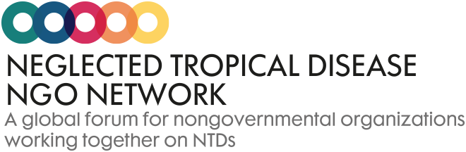
NNN Framework for Engagement
Annex 2: Terms of Reference: External Representation Group

1. Background
NTDs are a group of treatable and preventable diseases that continue to affect over one billion of the world’s most impoverished, marginalized people living in remote communities. Non-governmental organisations (NGOs) play a key role in the fight against these diseases.
The NTD NGO Network (NNN) is a global forum for NGOs to contribute to the control, elimination, and management of consequences of NTDs outlined within the internationally agreed World Health Organization’s (WHO) NTD Roadmap.⁹
Our vision is a world free of NTDs.
Our purpose is to enhance the contribution of NGOs towards that vision.
Our objectives to achieve our vision and purpose are:
- To be the unified NGO voice on common issues to achieve our NTD goals.
- To enhance our community of practice through membership engagement, learning and sharing knowledge.
Our values of participation, legitimacy, creativity and independence guide our NNN community in achieving these objectives.
The BEST framework provides NNN members with a platform for engagement, accountability and cross-sectoral action to support the achievement of the SDGs in respect of behaviour, the environment, social inclusion, equity, treatment and care to drive progress in achieving national and global NTD targets.
Our Membership is open to any NGO or academic institution¹⁰ that is engaged in the fight against NTDs. Other organisations are welcome to join our work as active observers.
The NNN is governed by an Executive Committee, comprised of representation from various NGO disease-specific groups and cross cutting groups, the External Representation Group and the Conference Committee that will enable the network to successfully meet the objectives of NNN.

2. Purpose of the External Representation Group (ERG)
This group provides strategic guidance to the NNN Executive Committee (ExCo) on policy influencing, advocacy and external communications. It facilitates engagement with the wider NTD community in the creation of policy positions and influencing work. The group leads on external influencing strategies through policy analysis, advocacy activities and communications activities, providing guidance and support to other groups within NNN where needed.
This group can also provide a platform for information sharing and Influencing collaboration with the growing number of national NTD coalitions and networks.
The key functions are:
• Consult with key stakeholders to form and guide the ‘voice’ of the NNN
• Identify key audiences for engagement and develop a work plan informed by annual priorities and relevant communications mechanisms (including the NNN website)
• Identify annual and ad-hoc engagement opportunities for influencing and make recommendations for activities including creation of policy and position statements to the ExCo where relevant.
• Draft content for influencing materials for the NNN Annual Conference statement, in consultation with others and for approval by the ExCo
• Represent the NNN on Uniting to Combat NTD’s Advocacy and Resource Mobilisation Group.
• Coordinate initiatives and collaborate with other NNN groups and committees.
• Provide opportunities for coordinated influencing by national coalitions and networks.
• Through membership of the ERG, provide opportunities for NNN members to learn about influencing strategies, activities and processes.
3. Membership of the ERG
The Group comprises of:
• An elected Chair
• An appointed Vice Chair
Or
• Elected Co-Chairs
And
• NNN Communications Lead
• By invitation, an NGO Representative from each of the national NTD coalitions
• Other interested members who can commit their time and resources to this active Group.

4. Elections
• The ERG Chair is elected by NNN Members at the Annual Conference for a two-year term.
• A Vice Chair can be appointed from within the Group to assist with the Chair’s responsibilities. This position holder does not automatically become the ERG Chair.

5. Roles and Responsibilities
Applicable to all:
• All members of the ERG Group should adhere to the values of the NNN in all their efforts and decision making
• All members should actively contribute to the ERG and attend the regular meetings
• All positions are voluntary and non-remunerated
The Chair:
• Chairs the ERG meetings
• Represents the ERG on the NNN ExCo, as well as its Steering Committee, and will act as the liaison between the wider NNN community and the ERG
• Reports back to NNN members at the Annual Conference on the ERG Annual Activities
Representation on Uniting ARM:
• One of the Members of the Group should be the appointed to represent the NNN on the Uniting to Combat NTD’s Advocacy and Resource Mobilisation Group.

END

All crosscutting groups and Diseases Specific Working Groups will continue to be responsible for the creation of technical and disease specific guidance. Where appropriate, the ERG will work with these groups to draw on their expertise for input into relevant materials for policy influencing, advocacy and communications, such as position papers or statements.

